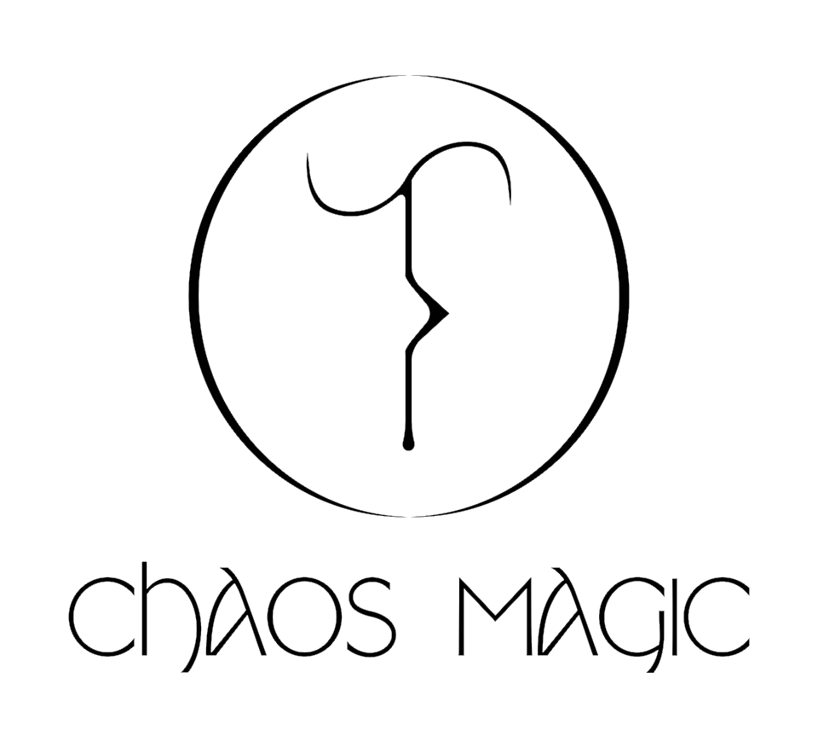

We are looking for a new Chaos Magic studio member!

Chaos Magic is an artist-led project space based within Backlit gallery, Nottingham. The studio is a shared, open plan space with an adjoining, purpose built gallery. We also maintain a community garden and outdoor exhibition space The Curious Tower in nearby St Mary’s rest gardens.

We are looking for new blood…

Chaos Magic is run by founder and director Joey Holder, head curator Wingshan Smith, studio manager Winter Beaumont, and our current members: Tomas Cobbett, Lily Hollywell, Francis Slip, Nellie O’, and Harry Martin.

The space is named after ‘chaos magick’ a postmodern esoteric belief system which aims to change reality through DIY occult ritual practice. Members of the space view chaos magick as a philosophy through which a fairer world can be manifested through creativity and community.

As a Chaos Magic member you will be welcomed into a friendly, inclusive, and democratic creative environment. You will have access to mentorship and a peer-to-peer learning network to support the development of your creative practice, and will be given the opportunity to curate, plan, and deliver a public arts programme spanning a diverse range of events, exhibitions, and workshops in collaboration with us.

Our spacious, beautiful, and well lit studio is shared between six members, with storage and individual desk spaces available to every studio member.

We want to give this opportunity to an enthusiastic and dedicated early career creative who has an interest in arts programming and running an art space, as well as the desire to support the Nottingham art scene whilst nurturing the community that surrounds it.

Rent is £75.84 per month, to be paid on the first of every month.
Our new member will be expected to join Chaos Magic on 1st April
The first month’s studio rent will be due on that date.

If you are interested please complete the application form below and attach 5 images of your work (jpeg/PDF). Please send your application to chaosmagicspace@gmail.com by the new moon at Midnight on Sunday 10th March 2024.
Please email us if you have any questions about the application process or if you would like to visit the space before applying.

We look forward to hearing from you!

Name:

Current city of residence:

Tell us about your art practice. (Max 200 words)

Tell us about any art & design education you may have completed, any relevant experience you have undertaken, and any previous history of running an art space. (Max 200 words)

Why are you interested in becoming a member of Chaos Magic? (Max. 200 words)

Give an example of an event, exhibition, or workshop that you would like to run. (Max 200 words)

